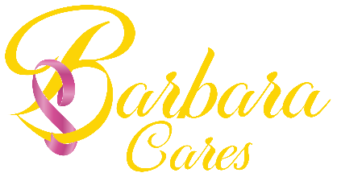
THE BARBARACARES FOUNDATION
December 14, 2021

Today is a very special day here at BarbaraCares, and I am delighted to celebrate it with each of you. Three years ago, the answer was ‘Yes’. Without all the details and without all the resources, the only thing that rang loud within was the call that something needed to be done! On December 14th, 2018 the BarbaraCares Foundation was officially started and registered with the Secretary of State here in Texas. The purpose was and remains to be a local, impactful grassroots advocate and resource for patients and caregivers facing a breast cancer diagnosis. As I reflect over these months and years that have so quickly passed by, I am truly grateful for the people that have helped build an organization from conception to reality.
In particular, I want to thank the Board of Directors for stewarding BarbaraCares with a heart of excellence, commitment, and innovation. The Board has been instrumental in the yearly growth of the organization and continues to make it possible for the organization to fulfill its mission. Three years - it's a turning point for most startup nonprofits and most don't last the first few years. We have been fortunate, even through a pandemic to have strategic plans in place to help safeguard the organization. I want to publicly thank our Board for helping to ensure BarbaraCares endures for the sake of the communities we serve across the state. As we look to the future, I am confident that the framework that has been laid and the values we hold dear will help carry us for years to come.

I often refer to the original 'Hope Box' that holds the ideas that Barbara Sanders-Holland had to help those on a breast cancer journey; the vision she created, the work she knew it would take, and the need to act immediately. With every applicant, we assist and with every mammogram we provide, my heart is overwhelmed by the lives we touch. In honor of Barbara and the others that have fought--and for the ones fighting, I commit to continue to champion the cause for health, wellness, and access to care for all.

I wish there were space and time to chronicle the highlights we have all experienced and the testimonials we have all heard, but I will say BarbaraCares is doing the work to help save and support lives across the state. Today we celebrate the milestones, the future and each of you that have in some part helped to make this organization what we are today. For every supporter, community sponsor, volunteer, and all support personnel ... I thank you! We are humbled for the chance to serve others. Please continue to join in our efforts to help those at-risk and those currently on this journey. And in the words of Barbara, we encourage you all to "Fight. Smile, & Fight Some More!"

Sincerely,

Xavier E. Sanders - Executive Director/Board Chair

